Ipsum IG Details

**TABLETOPS**

**Chui Marcus (Updates Via Facebook Group)**

**2) We Play Tabletop Boardgames!**

**3) Tembusu TableTops is an interest group that provides a platform for students to unwind and meet new people after a busy week. We're a group of board game enthusiasts with a treasure trove of wonderful games just itching to be uncovered. Whether you're as much of a board game geek as us or are just looking to chill for a while, all are welcome. We teach a new game every week, so don't be shy and you won't regret it!**

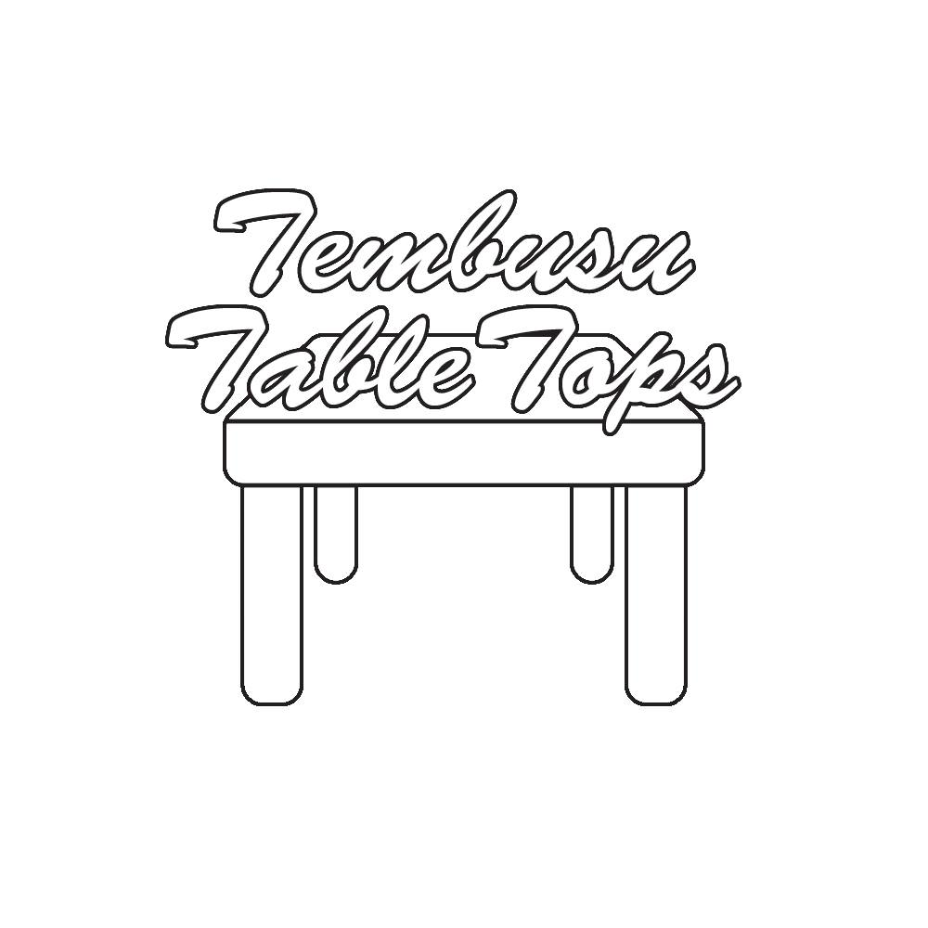

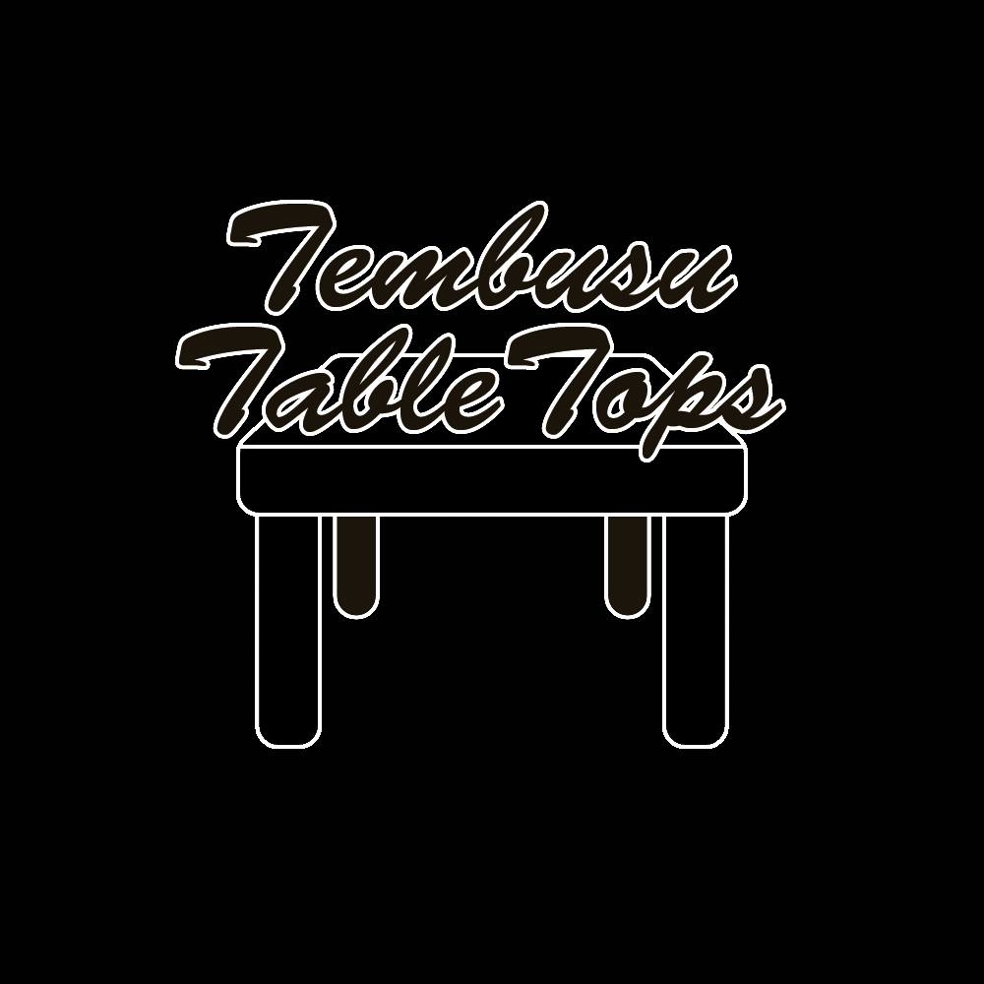

1) Andhieka Putra (andhieka.putra@gmail.com)  
2) Tembusu Guitar Ensemble  
3) Besides having weekly practice for small group performances, tGuitar also organises guitar talk and workshop sessions. tGuitar aims to spread the love and knowledge about the guitar to the residents of Tembusu College.



Ikhsan (ukebeats@tembusupac.org)  
  
ukuleleBeats@Tembusu  
  
We love the ukulele as much as it is possible to love an inanimate object without breaking the law. And the ukulele is the cutest instrument in the history of forever.

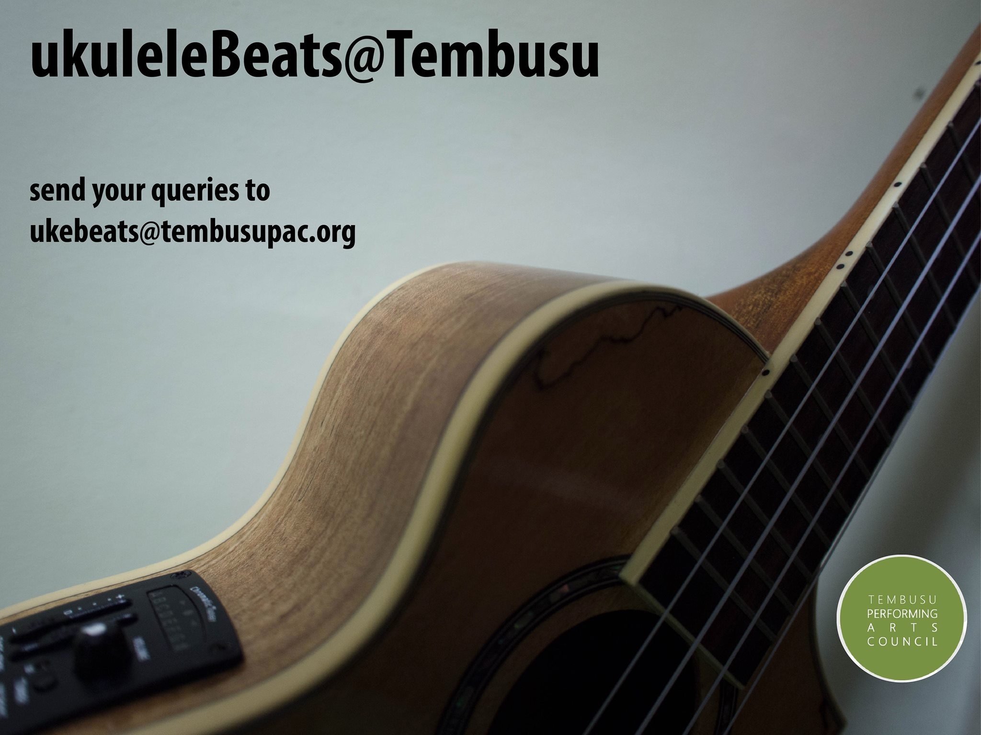

1) Li Zhenming tcrew.tembusu@gmail.com  
2) dance the street-style way  
3) One and only street dance group in Tembusu. Beside learning basic Hip Hop dance, there are also exposure to other genres such as breakdance, popping and locking. NO dance background is required.



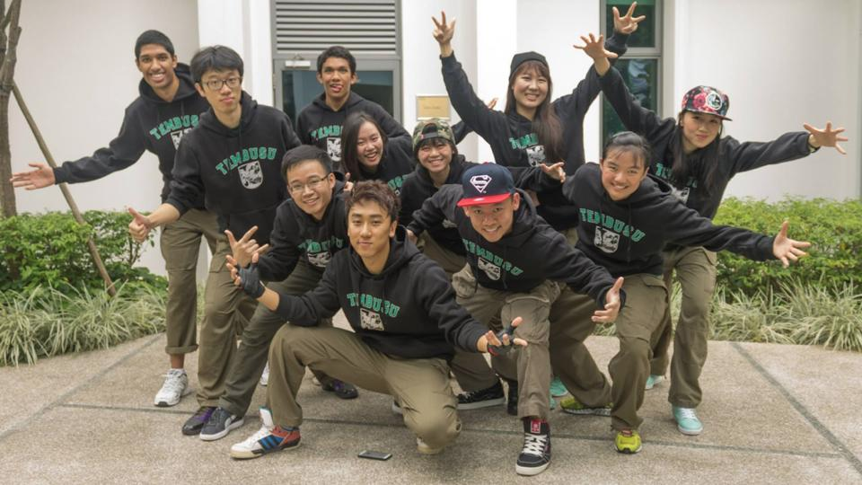

1) Danielle Goh (tembusutreblemakers15@gmail.com)  
2) Tembusu Treblemakers Acapella Group  
3) Proud of making music solely with our voices, the Tembusu Treblemakers is an a capella group passionate about singing and music. Name any song and we're keen to try it, singing a diversity of genres from your favourite billboard hits, jazz standards to disney tunes. From large scale performances to impromptu jamming sessions, there are tons of opportunities for anyone who loves to sing!

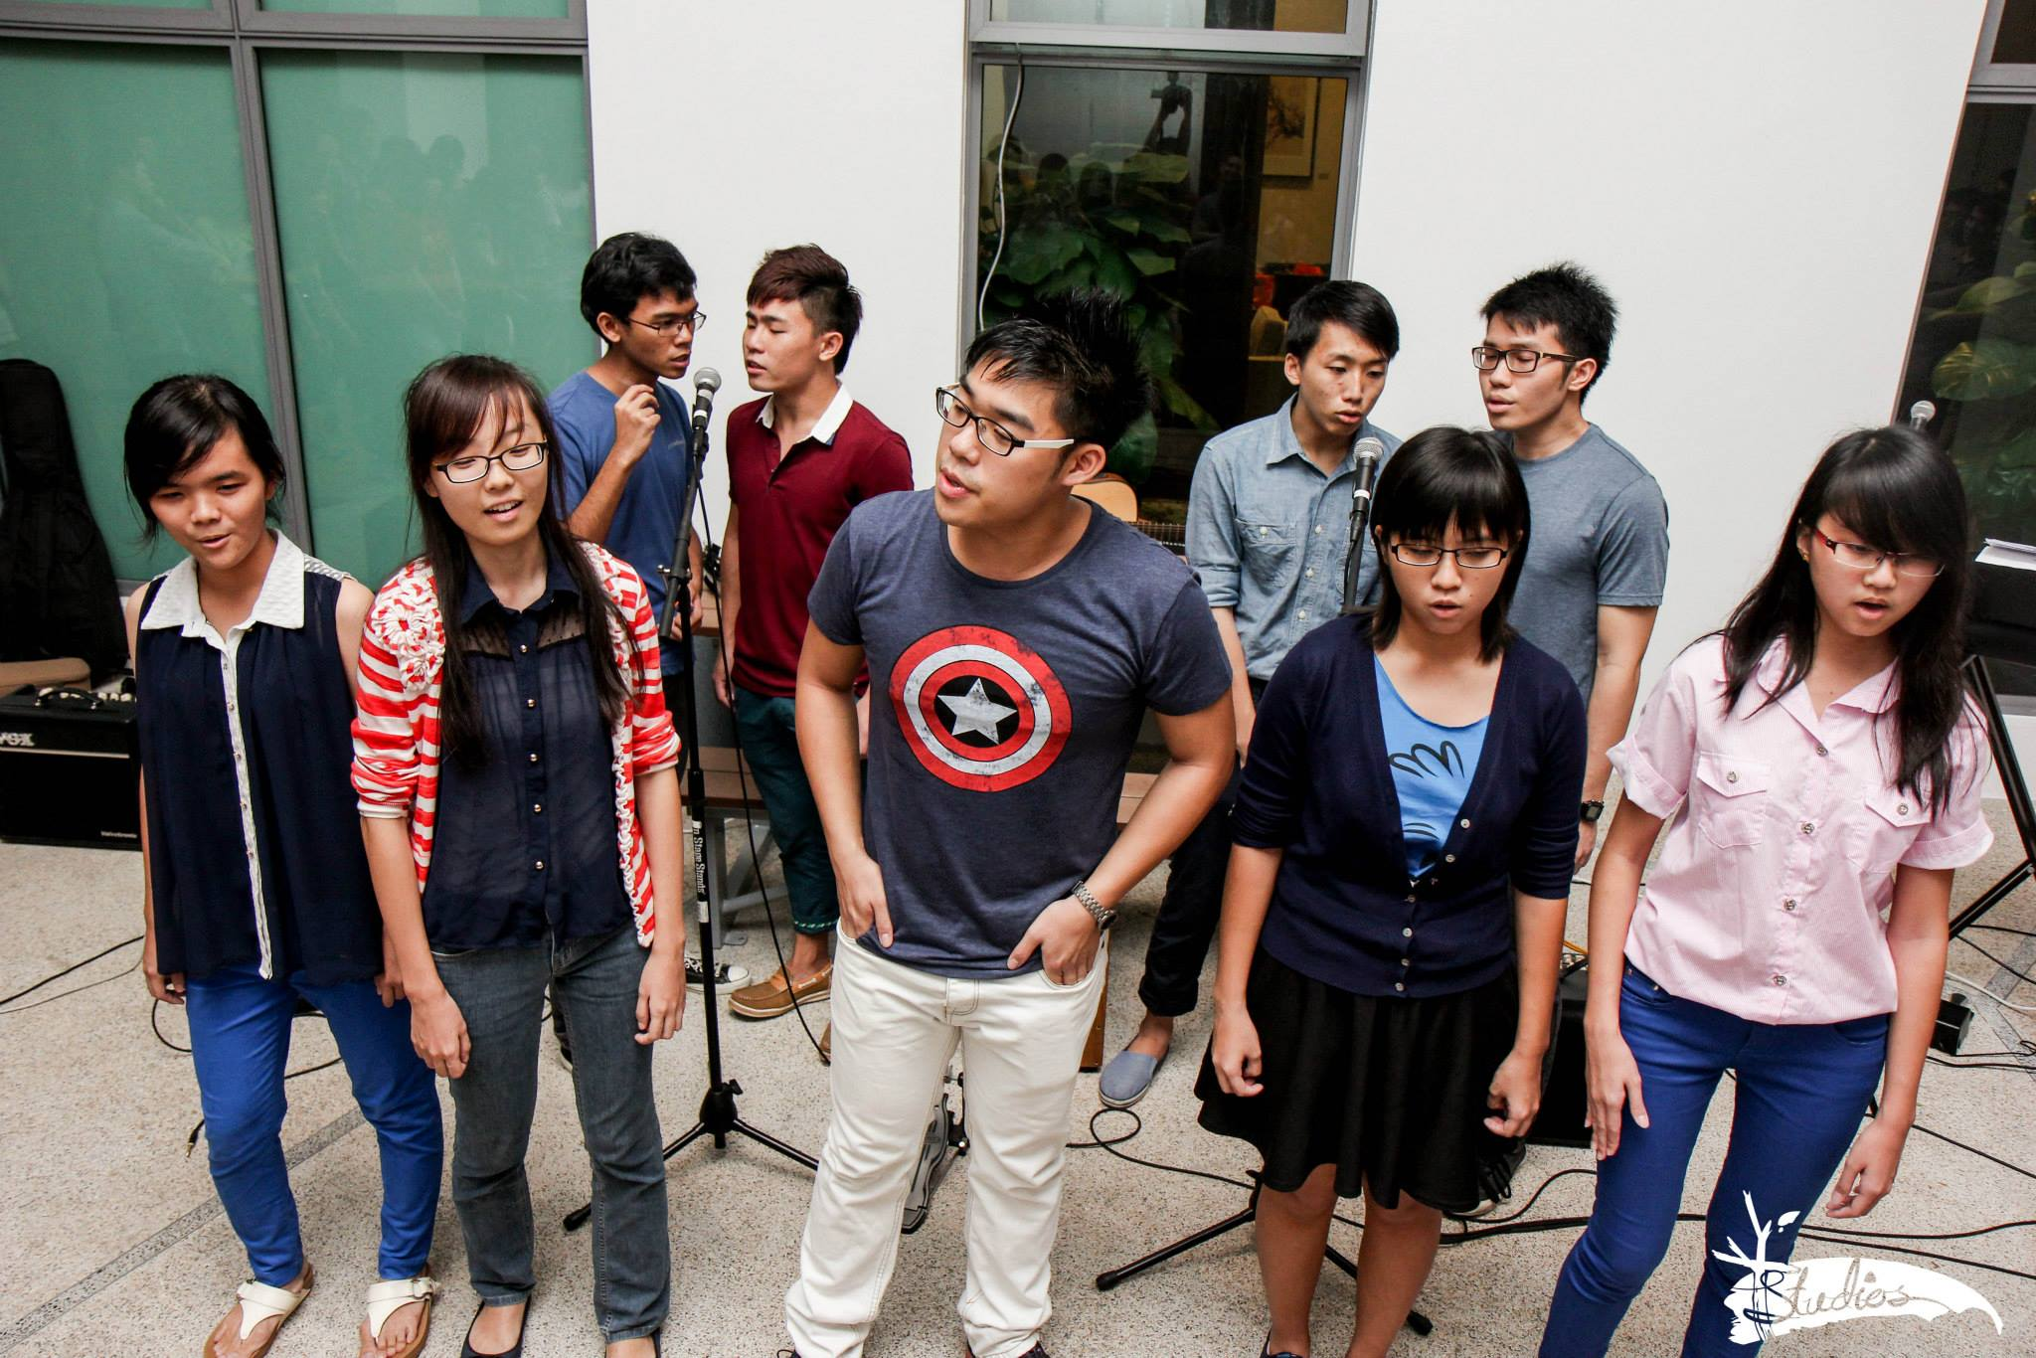

Bolt and Pace  
1) zhimin.sim@nus.edu.sg  
2) too fast too furious  
3) "it does not matter how fast you go or how far you go, it is the process that matters." bolt and pace was started as a community of people who enjoyed running. We have group runs as well as specific training sessions and cater to runners of all abilities.



Offtrek   
1) Clara Lim (lim.jiaying.clara@dhs.sg) OR Zhimin Sim (zhiminsim@gmail.com)  
2) Off the beaten track.  
3) We create interesting outdoor experiences for Tembusians to experience the best of nature and adventure. We have hiked locally (The Green Corridor Trail) and travelled abroad to Tioman. We are looking at more exciting activities to bring to you guys this semester!



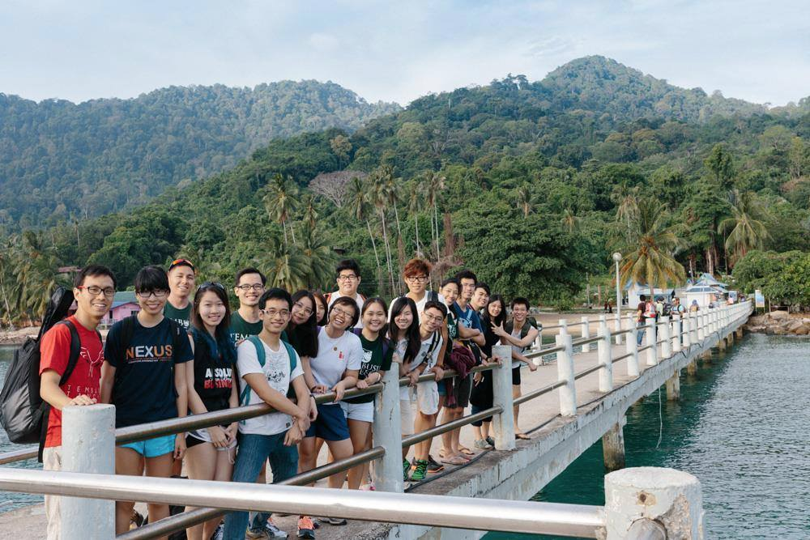

Tembudoodles  
1) Melissa Lim melcat.jy@gmail.com  
2) Anyone can doodle!  
3) A place for doodlers to share ideas, tips and inspiration on sketching and doodling! We also organize doodling sessions for everyone to try out different mediums and to encourage people to let out their artistic side.

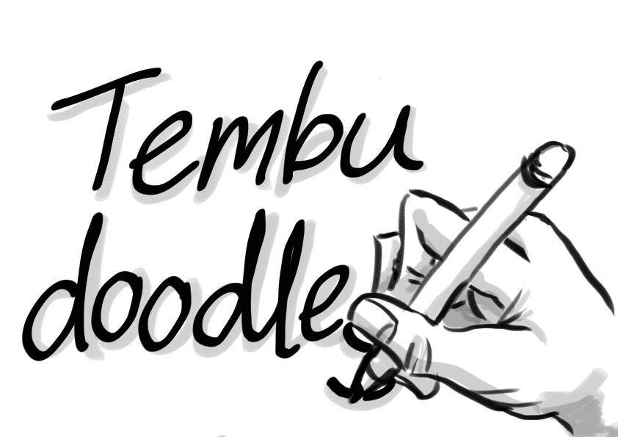

1) tKitchen (lee.chee.yann@nus.edu.sg)  
2) Cook. Bake. Eat.  
3) Because good food is made, not born. Because it's not too difficult anyone can cook and bake. And because we can't eat dining hall food anymore.  
[facebook.com/groups/tKitchen](https://www.facebook.com/groups/tKitchen/" \t "_blank)



IG: Debate Society   
IG head:Tan Yan Wei  
Contact: tan.yanwei@live.com  
Description: The debate society welcomes everyone with or without debate experience to join us! We have an excellent trainers who will teach you guys the basics of debate through weekly training sessions. Besides training we also organise several events such as our ‘Elephant in the Room’ series where we discuss controversial ideas as well as the annual Utown Intercollegiate Debate Tournament.



Tembusu Football  
1) Joseph Chan thisisjose9h@gmail.com  
2) Watch Talk Play Football  
3) We play the Beautiful Game in an extremely social and intensely recreational way  
4) Logo coming soon, sorry [Amit Gamane](https://www.facebook.com/amit.gamane" \t "_blank) and thanks!

1) Vivian Tan (viviantan1994@hotmail.com)  
2) K-Pop Dance  
3) We learn K-Pop choreography and add in our individual styles to create a unique performance! No experience required.

tMentors

1) Eurona Ang, refer to our website [http://tmentors.weebly.com/](http://tmentors.weebly.com/" \t "_blank) to signup. Or email euronaang@hotmail.com for any queries.

3) tMentors is a community outreach project that works with Newtown secondary school students on a weekly basis. Our mentors help them with their schoolwork and provide them with a listening ear. We are always brainstorming for new ideas and initiatives to motivate our mentees and to show them that there is a world beyond mere academic pursuits.

